Join St. Peter’s for Water Play Day!!

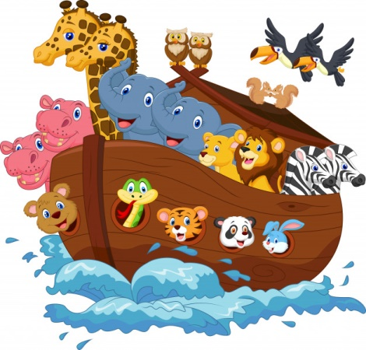
WHEN: Saturday, August 10th
WHO: All children ages 3 - 12
TIMES: Ages 5-8: 9am - 11am
Ages 3&4: 11:30am - 1:30pm
Ages 9-12: 2pm - 4pm

WHERE: St. Peter's Episcopal Church
104 Elm Street, Sheboygan Falls

Bring your children for a two-hour session of Water Play based on the popular Bible story Noah's Ark!
Parents: Feel free to stay or simply drop off your children with our trained staff members.
Wear your suit and bring a towel because we’ll be playing water games, having fun with water balloons, and even a slip n’ slide! We’ll learn about water safety and compassion for all of God's creatures!
Snacks provided—we will have animal-themed treats!
Questions? Contact Julie or Marissa at children@stpetersfalls.org

